Overview

What is Pockigo?
Pockigo is a travel planning platform that creates personalized itineraries based on users’ preferences and needs. Travelers can view, edit, and optimize their plans while accessing all essential information in one place. It is available on both the web and mobile. In this case study, we worked on the first task, “Getting a personalized itinerary” on the web. We worked on the second task, “Tracking the itinerary”, on mobile in another case study (link).

What is the user’s task in this case study?
User wants to get a personalized trip plan before their trip.

Problem statement

Business needs
- Provide a personalized itinerary based on destination, date or trip duration, and user’s interests.
- Allow user to modify the itinerary with ease.
- Offer an interactive map view.
- Allow user to share the itinerary with their travel buddy.
- User can access their past, active and upcoming plans anytime.
- Book activities

Design Goals
- Comprehensive and accurate filtering system
- Easy to use for people of all ages
- A smooth and convenient navigation
- Visually appealing and functional interface.

Design method
My team of 5 ran a double Diamond method based on the Design Thinking Methodology. It was not a linear path, we bounced between stages as the project progressed.
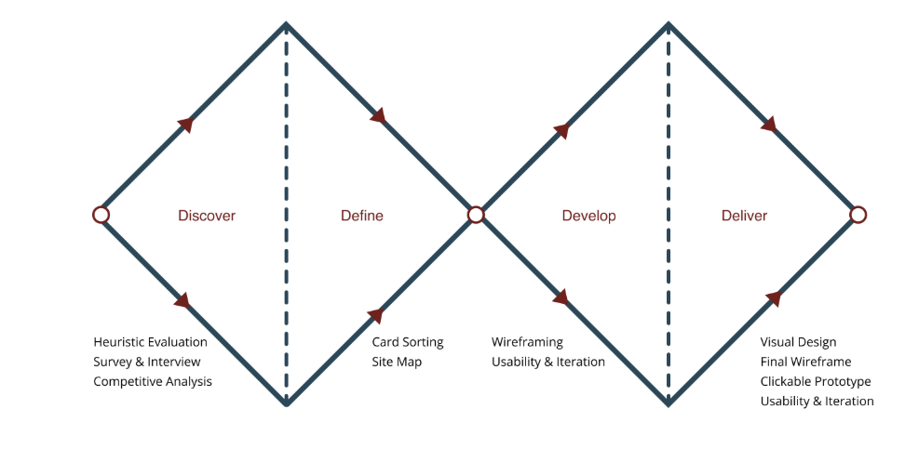

Discover
In the Define phase, we synthesized insights from our research to clarify user needs and pain points.

Interview
We started by conducting interviews with 20 potential participants to understand their common needs and pain points.
Interview goals: To understand how different travelers plan trips, what frustrates them, and what they expect from a tool that manages their itinerary.

Affinity diagram
By organizing the research findings into an affinity diagram, we identified the key themes that represent users’ main needs and pain points. Below are the insights that guided the design.
Common User Needs and Pain Points
- An overwhelming number of options to choose from.
- Concerns about travel distances between activities that could affect time efficiency.
- Difficulty finding precise informations about activities scattered on the internet.
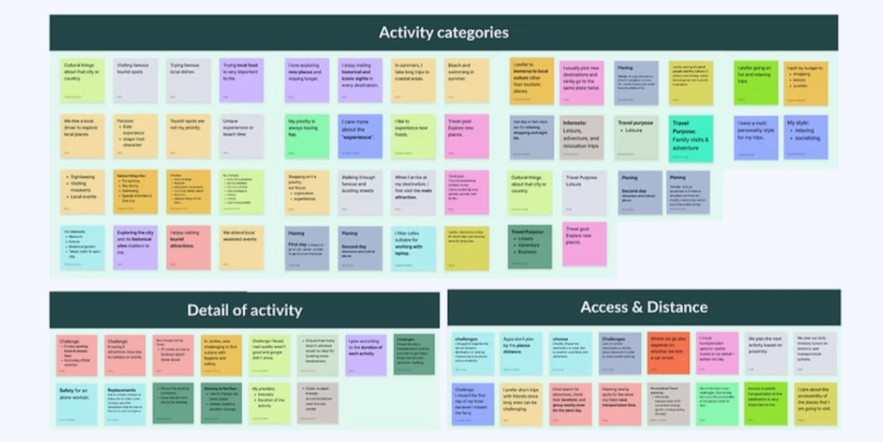

Competitive analysis
We conducted a competitive analysis to identify how existing products approach similar problems, pinpoint their weaknesses, and recognize effective patterns we could build on or improve.

We looked at some of the most popular travel planning platforms and compared their features side-by-side and analyzed how closely they compare to what we’re building.
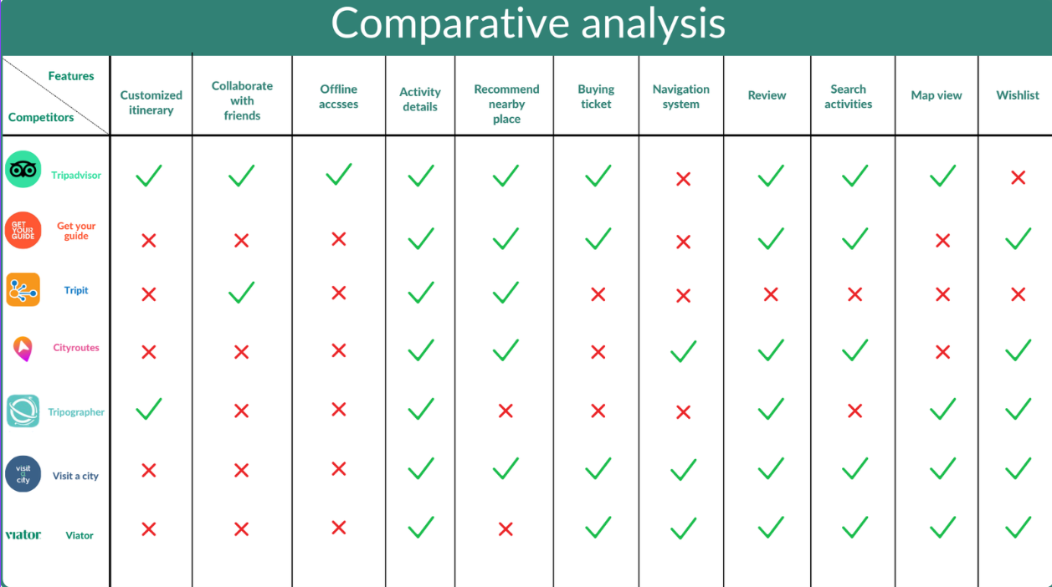
We identified Tripadvisor, GetYourGuide, and Tripographer as our main competitors and analyzed their weaknesses:
- Tripadvisor – Missing “Get Itinerary” button, limiting quick access to plans.
- GetYourGuide – Low task efficiency and no direct itinerary access.
- Tripographer – Poor navigation, limited category variety, and weak activity readability.
By studying these pain points, we ensured Pockigo avoids the same issues. We also drew from their strongest features to create a user flow that is intuitive, efficient, and easy to follow for our target audience.
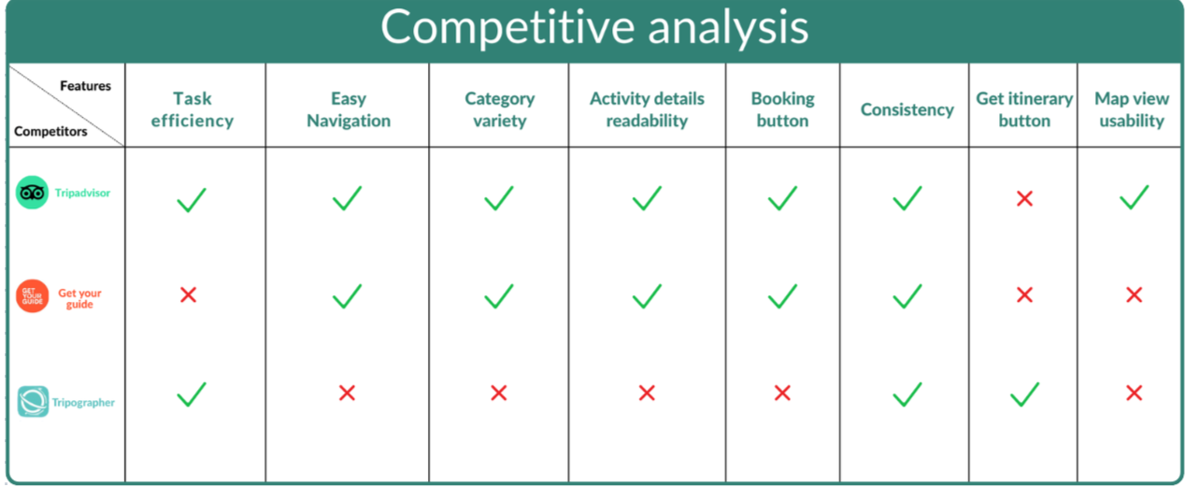

Card sorting
To define clear and intuitive categories for activities in Pockigo, we explored activities in Granada and ran a card-sorting session with 6 participants. They grouped the activities into categories and suggested labels, helping us validate the structure and choose names that matched users’ mental models.
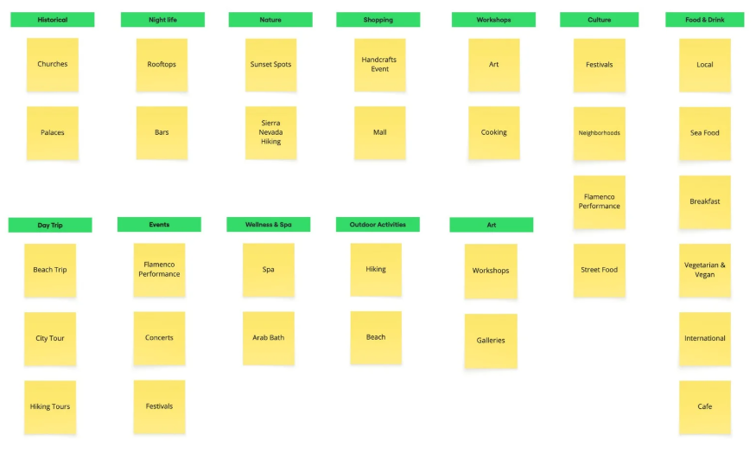

Define

Persona
To define key tasks for our design and clearly convey the user insights gathered during research, we created a persona along with a scenario.
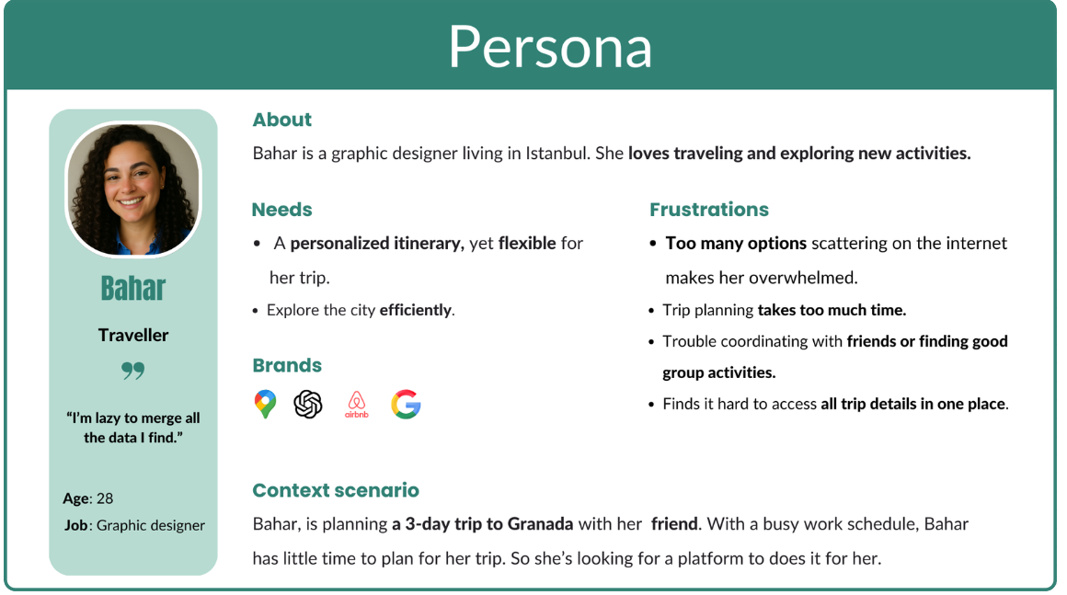

Sitemap
The site map shows the structure of pages and categories, ensuring users can easily navigate and find activitie
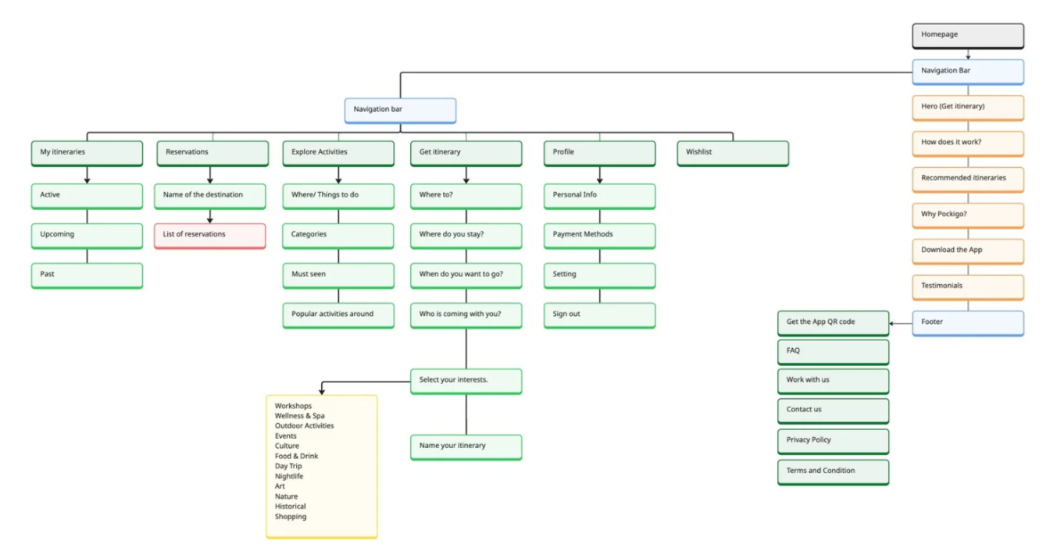

Scenario
Bahar is gonna travel to Granada, Spain with a friend for the first time. She needs an itinerary suitable for a friends trip. She opens Pockigo’s website and start to get an itinerary. She answers the questions about the destination, date and choose their interests. She gets the itinerary and shares it with her friend.
Here is the task flow for this scenario

Develop

Ideation
We generated a wide range of ideas to address the key user needs and pain points identified during research. These concepts explored different approaches for page layouts, user flows, and interactions. The best solutions were then selected and refined to move forward into wireframing.
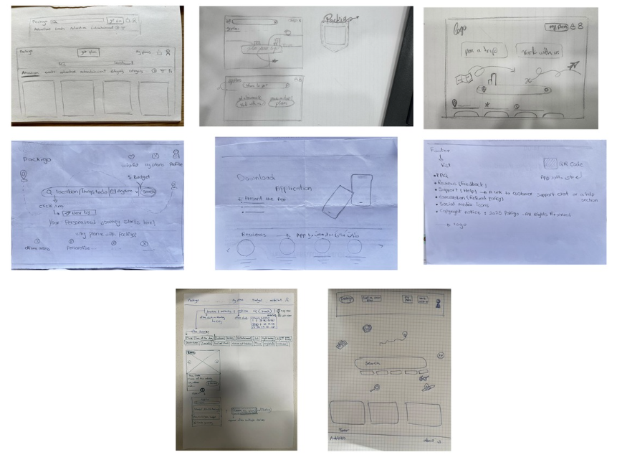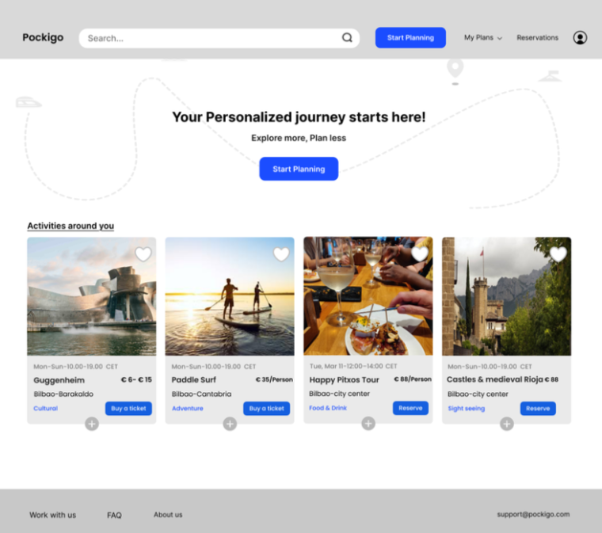

Low fidelity wireframes

Deliver

UI design

Usability testing

High fidelity Prototyping

